**INTEL 8085 ARCHITECTURE**

**Diagram**

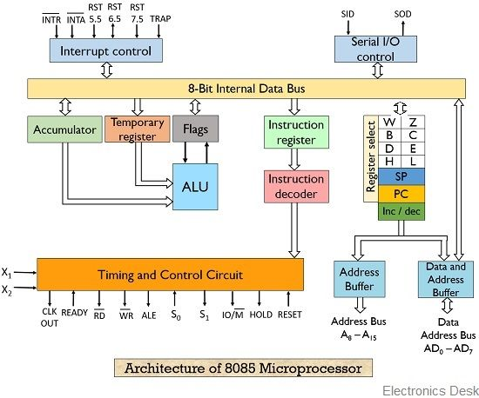

**Information**

* **Accumulator:** Default register used for **special purposes** like arithmetic & logical operations.
* **Temporary register:** **Temporarily** stores data.
* **General-purpose registers:** B, C, D, E, H, L. Involved in **data movement**.
* **Stack pointer:** Points to **memory addresses** stored in **stack**.
* **Program counter:** Points to the **next instruction** to be executed.
* **Instruction register:** **Temporarily** stores the **currently** executing instruction.

**Flags**

* **Sign flag (S):** Tells **sign** of a binary number as per **MSB**.
* **Zero flag (Z):** Raised when the result of an operation is **0**.
* **Auxiliary carry flag (AC):** Raised if carry **increases the digit** in BCD.
* **Parity flag (P):** Raised if the number of **set bits** in result is **even**.
* **Carry flag:** Same as auxiliary carry flag (AC) but with **regular binary** numbers.
* **Set bit:** 1s

**I/O and Memory Interfacing**

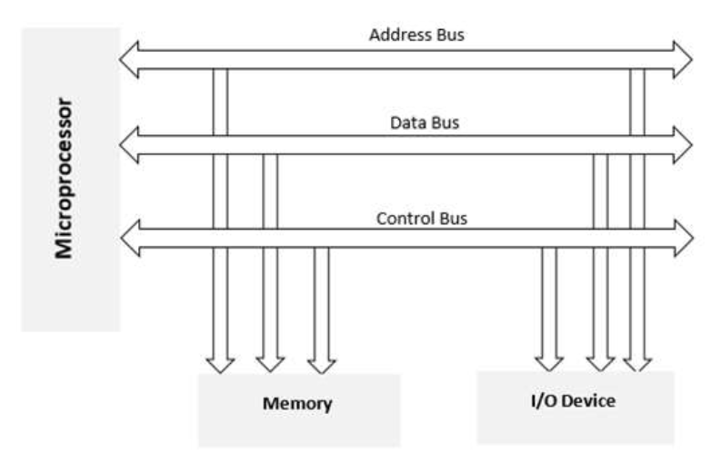

* I/O devices are interfaced using **latches** and **buffers**.

Interfacing pins:-

* **A15 – A8** (higher address bus)
* **AD7 – AD0** (Lower address/data bus)
* **ALE**
* **RD**
* **WR**
* **READY**

**Communication Interfaces**

* **Serial communication interface:** When the interface receives **1 byte** of data from microprocessor, it sends it **bit by bit** in **series**.
* **Parallel communication interface:** Sends **all bits** or **some bits parallely**.